Remote Configuration of Multi-Channel Electronics FPGAs
Rev. 1.0
Revision History
Rev. | Date | Author | Description of change
1.0
Table of Contents
Abstract 1
1. Introduction 1
2. Hardware Description 2
2.1 Bypass Circuitry on Backplane 2
2.2 JTAG-port Select 2
2.3 Flash and SRAM Storage 2
3. Embedded Configuration Solutions 3
3.1 Programming Methods 3
3.1.1 Flash Interface to EPC Devices 3
3.1.2 JRunner 3
3.1.3 JAM Player 4
3.2 File Format Options 4
3.2.1 ISC or IEEE 1532 4
3.2.2 RBF 4
3.2.3 JAM 4
3.2.4 JBC 5
4. References 5

Abstract
This document describes the remote configuration of multi-channel electronics (MCE) FPGAs over the fibre interface to the RTL PC. Different alternatives, the adopted method, and details of implementation are discussed.

Introduction
Each board in the MCE subrack with the exception of power-supply card has an Altera FPGA and an on-board EPC configuration device. Clock card (CC) has an additional EPC configuration device to store the factory configuration. All FPGAs and configuration devices with the exception of the factory-configuration EPC device are part of the same JTAG chain. The chain can be driven through the CC FPGA IO lines presumably controlled by FPGA logic or alternatively through the front-panel connector controlled by a USB-Blaster. This document discusses the implementation of a JTAG controller in CC FPGA to provide a facility to remotely configure the subrack by issuing commands to the CC. The basic requirements are:
- Total configuration time of less than 5 minutes (requirement (e) in section 4.8.1 of [5]).
- Remote configuration to be initiated from RTL PC (requirement (k) in section 4.8.1 of [5]) and configuration file to be transferred over the fibre interface between the CC and RTL PC.
- The factory-configuration EPC device is only accessible through the on-board JTAG header.

Hardware Description
There are total of 18 devices on the JTAG chain. The order of devices in the chain is last to first such that Address-card FPGA is the first device and CC FPGA is the last device in the chain.

Bypass Circuitry on Backplane
When the subrack is not fully populated, the continuity of the JTAG chain is guaranteed through the bypass bus switches (SN74CBTLV126) that are present on the back plane.

JTAG-port Select
Figure 1 shows the CC circuitry that selects (JTAG_sel) whether the JTAG port is controlled by the FPGA (through FPGA IO pins) or by USB-Blaster (through fron-panel connector). JTAG-Sel is also controlled by the FPGA. Therefore, the FPGA-based JTAG controller first asserts the JTAG-sel pin to take control of the JTAG port and remove the CC FPGA from the JTAG chain and then configures the rest of the devices in the chain.
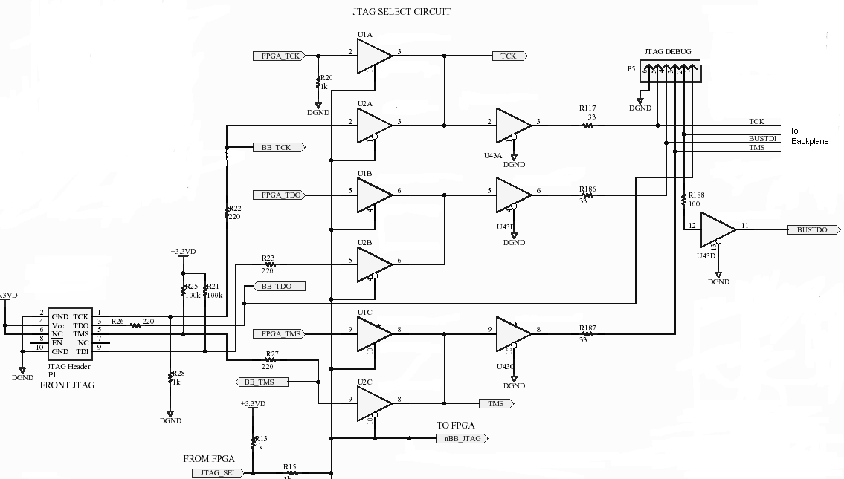
Figure 1: Selecting JTAG-Control Circuitry (copied from CC schematics)
The factory configuration mainly includes the JTAG controller and basic functionality to communicate with data-acquisition PC. Reconfiguration can be triggered on any card by issuing a JAM-player command that asserts the nINIT_CONF pin on a specific FPGA.

The preliminary plan is to instantiate a NIOS core in CC FPGA to run the JTAG controller. The application code for NIOS can be either stored in on-chip SRAM or the non-configuration part of the flash memory of Factory EPC16.

Flash and SRAM Storage
There are 2MB of external SRAM storage available on CC configured as two 1Mx16 (CY7C1061AV33). The intention is to store the configuration data in the SRAM prior to programming Application EPCs of any card.
Each EPC device has 2MB of flash memory. The EPC devices that we use have the Sharp Flash LHF16J061 that offers 2 boot blocks and 31 main data blocks. The idcode for an EPC16 device with Sharp Flash is 0x00B000E9. Here is the Flash memory map:
0x000000 – 0x008000 Boot/Parameter blocks (relative addressing)
0x008000 – 0x00801F Opton bits (Configuration Space)
0x008020 – 0x??????? Configuration pages
0x??????? – 0xFFFFFF Application Code
The flash interface for the Application EPC is not wired, but the flash interface for the Factory EPC is wired to the FPGA.
Depending on the implementation details of the CC firmware, the CC may benefit from use of Remote/Local Configuration Mode [4]. All of the other Stratix devices use the Standard FPP configuration mode. However, it would be sensible to provide hardware links such the configuration mode of all the Stratix devices could be changed if necessary.

Note that to ensure that the EPC device is successfully programmed, the flash interface pins have to be tri-stated by the controller that is driving this interface to avoid contention. This implies that if the sof in the FPGA is driving those pins, then we have to first switch to application configuration and then reprogram Factory EPC.

Embedded Configuration Solutions
There are different tools and file formats available to configure Altera devices. The following section lists the options.

Programming Methods
A likely scenario is to program the factory EPC to run a JAM player and then program all EPCs through the JTAG connector driven by CC FPGA. Why then not just program FPGA’s with sof?

Flash Interface to EPC Devices
The flash memory inside the EPC device can be divided into two categories: logical (configuration and processor space) and physical (flash data block boundaries. Configuration space consists of portions of memory used to store configuration option bits and configuration data. Processor space consists of portions of memory used to store boot and application method.
The flash memory can be programmed through the parallel flash interface by directly communicating to the Flash. Note that the flash interface for the Application EPC is not wired and the flash interface for Factory EPC on CC is wired.

JRunner
JRunner is a portable windows-based application to program raw binary files (rbf) into SRAM-based Altera devices via JTAG interface. Hence, it can not be used to program EPC devices.
JRunner 1.7 is the latest version that can be downloaded from Altera website. Jrunner, runs on NIOS board consistently, but fails on MCE. needs further investigation. JRunner takes a cdf file as input. The cdf file, created by Quartus, has to be updated as follows before it can be used by Jrunner:
- change sof extension to rbf
- add instruction-register length parameter
The rbf filesize for 1s10 is 430kB as oppose to 1.2MB sof file. EPC devices support JTAG-based ISP mode which is basically IEEE 1532.

JAM Player
The Jam standard test and programming language (STAPL) is a file format defined by Altera that contains device algorithms and user data. The Jam solution consists of 2 components: Jam composer and Jam player. Jam Composer is vendor specific, but jam files and jam players are presumably vendor-independent.
Quartus is used as Jam composer to create Jam files. From the newsgroups, it seems that JAM bytecode player provided by Altera only supports JAM Rev. 1 format and Quartus generates JAM Rev. 2 format.
Jam player reads jam files and applies vectors to test or configure programmable JTAG devices.Altera provides a tool called JP

File Format Options

ISC or IEEE 1532
IEEE 1532 refers to an industry standardization effort aimed at simplifying the challenge of programming in-system-configurable (ISC) devices using the industry-standard IEEE 1149.1 boundary scan test-access port. The IEEE 1532 effort is focused on the standardization of the programming algorithm at the component level (silicon) as well as the definition of the software required to describe the programming algorithm and associated programming data.
Any device which claims compatibility or compliance with this standard will support ISC commands as defined by the standard. The software portion of the IEEE 1532 standard defines a modified bsdl file (ISC BSDL file) which has been expanded to cover the new ISC instructions. Additionally, there is a new data file (ISC Data file) which contains all of the device and pattern-specific programming data.
Altera provided ISC BSDL files for EPC devices. A sample file was generated for 1S10. Filesize is 1.5MB.

RBF
Altera Quartus Software can be used to generate raw binary format (RBF) files. Altera provides a tool called JRunner that is developed to configure Altera SRAM-based programmable logic devices (PLDs)
in JTAG mode for embedded configurations. Source code for JRunner is available, but unfortunately, JRunner does not support EPC devices.

JAM
The Jam standard test and programming language (STAPL) is a file format defined by Altera that contains device algorithms and user data.
Here are actions defined as per Jam standard:
JAM files
Stratix®  Stratix II | Configure | do_read_usercode  do_halt_on_chip_cc  do_ignore_idcode_errors Read_usercode -
Enhanced Configuration  Devices | Program | do_blank_check  do_secure do_read_usercode  do_init_configuration
 | Blankcheck -
 | Verify | do_read_usercode
 | Erase | -
 | Read_usercode | -
 | Init_configuration | -

JAM Instruction Names

BOOLEAN INTEGER PREIR
CALL IRSCAN PRINT
CRC IRSTOP PUSH
DRSCAN LET RETURN
DRSTOP NEXT STATE
EXIT NOTE WAIT
EXPORT POP VECTOR (1)
FOR POSTDR VMAP (1)
GOTO POSTIR -
IF PREDR -

(1) This instruction name is an optional language extension.

I tried jp_25/jam with rc firmware for 1s40 and EPC separately and both works.
Note that jam file sizes are: 3.7MB

JBC

NIOS boot-up options:
Stratix SRAM
EPC Flash

Programming time
Using USB Blaster and Quartus 6.1, programming (Erase/Program) Factory EPC16 on clock card takes 3min+28sec. Verifying takes only 1min+20sec.
Estimated programming time for full subrack= 3.5*9=31.5min.

References
[1] ‘Multichannel Electronics Block Diagram’, SC2_ELE_S560_001.
[2] ‘Stratix FPGA Configuration’, SC2/ELE/S500/21.
[3] ‘MCE Engineering Description’, SC2/ELE/S565/000
[4] ‘AN 217: Using Remote System Configuration with Stratix & Stratix GX Devices’, AN-217-2.1,
Altera Corp.
[5] ‘Multichannel Electronics Requirements and Recommendations’, SC2/ELE/S500/11.
[6] ‘FPGA Configuration Block Diagram’, SC2_ELE_S560_003.
[7] ‘Clock Card Configuration Scheme Schematic Capture’ SC2/ELE/S565/103/001
[8] ‘AN 208: Configuring Stratix & Stratix GX Devices’, AN-208-2.2, Altera Corp
[9] ‘Stratix FPGA Family Data Sheet’, DS-STXFAMLY-3.0, Altera Corp.
[10] ‘ByteBlasterMV Parallel Port Download Cable Data Sheets’, DS-BYTBLMV-3.3, Altera Corp.
[11] ‘Using the JAM Language for ISP & ICR via an Embedded Processor’ Altera Application Note 088
[12] ‘CC Dual-EPC16 Configuration Block Diagram’, SC2_ELE_S565_003_000
[13] ‘Using the Intel Flash Memory-Based EPC4, EPC8& EPC16 Devices’, White Paper, Altera, Oct. 2005.

